
PATUAKHALI SCIENCE

AND TECHNOLOGY
UNIVERSITY
COURSE CODE CCE-223
SUBMITTED TO:
Dr. Md. Samsuzzaman
Department of Computer and Communication Engineering
Faculty of Computer Science and Engineering

SUBMITTED BY:
NAZMUS SAKIB
ID: 2102066
Registration No: 10193
Faculty of Computer Science and Engineering

Date of submission: 31 March, 2025
Assignment: Chapter 4 (solve)

Chapter 04
Practice Exercises:
4.1 Consider the following SQL query that seeks to find a list of titles of all courses taught in Spring 2017 along with the name of the instructor.
select name, title
from instructor
natural join teaches natural join section natural join course
where semester = “Spring” and year = 2017
What is wrong with this query?
Ans:
The query is correct but gives the wrong result because dept_name is in both course and instructor tables. A NATURAL JOIN matches them automatically, so it only shows courses taught by instructors in their own department.

4.2 Write the following queries in SQL:
- Display a list of all instructors, showing each instructor's ID and the number of sections taught. Make sure to show the number of sections as 0 for instructors who have not taught any section. Your query should use an outer join, and should not use subqueries.
Ans:
select ID, count(sec_id) as Number of sections
from instructor natural left outer join teaches group by ID

- Write the same query as in part a, but using a s alar subquery and not using outer join.
Ans:
select ID, (select count(*) as Number of sections from teaches T where T.id = I.id) from instructor I

C. Display the list of all course sections offered in Spring 2018, along with the ID and name of each instructor teaching the section. If a section has more than one instructor, that section should appear as many times in the result as it has instructors. If a section does not have any instructor, it should still appear in the result with the instructor name set to ‘_’ .
Ans:
select course_id, sec_id, ID,
decode(name, null, '*', name) as name
from (section natural left outer join teaches) natural left outer join instructor where semester='Spring' and year= 2018

d. Display the list of all departments, with the total number of instructors in each department, without using subqueries. Make sure to show departments that have no instructors and list those departments with an instructor count of zero.
Ans:
select dept name, count(ID)
from department natural left outer join instructor group by dept name
4.3 Outer join expressions can be computed in SQL without using the SQL outer join operation. To illustrate this fa t, show how to rewrite each of the following SQL queries without using the outer join expression.
- select * from student natural left outer join takes
select * from student natural left outer join takes an be rewritten as: select * from student natural join takes union
select ID, name, dept name, tot red, null, null, null, null, null from student S1 where not exists
(select ID from takes T1 where T1.id = S1.id)

- select * from student natural full outer join takes
Ans:

select * from student natural full outer join takes an be rewritten as:

(select * from student natural join takes)
union (select ID, name, dept name, tot red, null, null, null, null, null from student S1 where not exists
(select ID from takes T1 where T1.id = S1.id))
union (select ID, null, null, null, course id, se id, semester, year, grade from takes T1 where not exists
(select ID from student S1 whereT1.id = S1.id))
4.4 Suppose we have three relations r(A, B), s(B, C), and t(B, D), with all attributes de lared as not null.
- Give instances of relations r, s, and t such that in the result of (r natural left outer join s) natural left outer join t attribute C has a null value but attribute D has a non-null value.
Ans:
Consider r = (a, b), s = (b1, 1), t = (b, d). The second expression would give (a, b, null, d).
- Are there instances of r, s, and t such that the result of r natural left outer join (s natural left outer join t) has a null value for C but a non-null value for D? Explain why or why not.
Ans:
Since s natural left outer join t is computed first, the absence of nulls is both s and t implies that each tuple of the result an have D null, but C can never be null.

4.5 Testing SQL queries: To test if a query specified in English has been correctly written in SQL, the SQL query is typically executed on multiple test databases, and a human checks if the SQL query result on each test database matches the intention of the specification in English.
- In Section 4.1.1 we saw an example of an erroneous SQL query which was intended to find which courses had been taught by each instructor; the query computed the natural join of instructor, teaches, and course, and as a result it unintentionally equated the dept name attribute of instructor and course. Give an example of a dataset that would help at h this particular error.
Consider the case where a professor in the Physics department teaches an Elec. Eng. course. Even though there is a valid corresponding entry in teaches, it is lost in the natural join of instructor, teaches and course, sin e the instructor's department name does not match the department name of the course. A dataset corresponding to the same is:

instructor = {(‘12345’,'Gauss', 'Physics', 10000)} teaches = {(‘12345’, 'EE321', 1, 'Spring', 2017)} course = {('EE321', 'Magnetism', 'Elec. Eng.', 6)}

- When creating test databases, it is important to create tuples in referenced relations that do not have any matching tuple in the referencing relation for each foreign key. Explain why, using an example query on the university database.
Ans:
The query in question 4.2(a) is a good example for this. Instructors who have not taught a single course should have number of sections as 0 in the query result.

- When creating test databases, it is important to create tuples with null values for foreignkey attributes, provided the attribute is nullable (SQL allows foreign-key attributes to take on null values, as long as they are not part of the primary key and have not been declared as not null). Explain why, using an example query on the university database.
Ans:
Consider the query :
select * from teaches natural join instructor;

In this query, we would lose some sections if teaches.ID is allowed to be null and such tuples exist. If, just be cause teaches.ID is a foreign key to instructor, we did not create such a tuple, the error in the above query would not be detected.
4.6 Show how to define the view student grades (ID, GPA) giving the grade-point average of each student, based on the query in Exercise 3.2; recall that we used a relation grade points (grade, points) to get the numeri points associated with a letter grade. Make sure your view definition correctly handles the case of null values for the grade attribute of the takes relation.
Ans:
We should not add credits for courses with a null grade; further, to correctly handle the case where a student has not completed any course, we should make sure we don't divide by zero, and should instead return a null value. We break the query into a subquery that finds sum of credits and sum of credit-grade-points, taking null grades into a count The outer query divides the above to get the average, taking are of divide by zero.

create view student grades (ID, GPA)
as select ID, credit points / decode (credit_sum, 0, null, credit_sum)
from ((select ID, sum (decode (grade, null, 0, credits)) as credit_sum,
sum (decode (grade, null, 0, credits*points)) as credit points
from (takes natural join course) natural left outer join grade points
group by ID)
union select ID, null, null
from student where ID not in (select ID from takes))

The view defined above takes are of null grades by considering the credit points to be 0 and not adding the corresponding credits in credit_sum.
4.7 Consider the employee database of Figure 4.12. Give an SQL DDL definition of this database. Identify referential-integrity constraints that should hold, and in lude them in the DDL definition.
Ans:
Note that alternative data types are possible. Other choices for not null attributes may be acceptable.
4.8 As discussed in Section 4.4.8, we expect the constraint an instructor cannot teach sections in two different classrooms in a semester in the same time slot to hold.
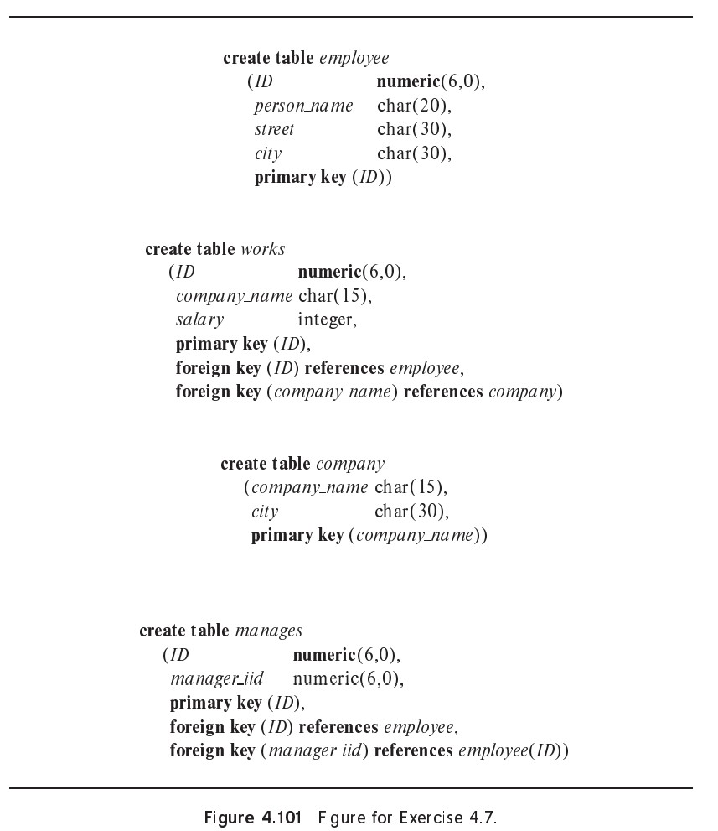
- Write an SQL query that returns all (instructor, se tion) combinations that violate this constraint.
select ID, name, se id, semester, year, time slot id, count (distinct building, room_number)
from instructor natural join teaches natural join section
group by (ID, name, sec_id, semester, year, time_slot_id)
having count (building, room number) > 1

- Write an SQL assertion to enforce this constraint (as discussed in Section 4.4.8, current generation database systems do not support such assertions, although they are part of the SQL standard).
Ans:
create assertion heck not exists
( select ID, name, sec_id, semester, year, time_slot_id, count(distinct building, room_number) from instructor natural join teaches natural join section
group by (ID, name, sec_id, semester, year, time_slot_id) having count(building, room number) > 1)
4.9 SQL allows a foreign-key dependen y to refer to the same relation, as in the following example:
create table manager (employee_ID char(20), manager_ID char(20),
primary key employee_ID, foreign key (manager_ID) references manager(employee_ID) on delete cascade )

Here, employee_ID is a key to the table manager, meaning that each employee has at most one manager. The foreign-key clause requires that every manager also be an employee.
Explain exactly what happens when a tuple in the relation manager is deleted.
Ans:
The tuples of all employees of the manager, at all levels, get deleted as well! This happens in a series of steps. The initial deletion will trigger deletion of all the tuples corresponding to direct employees of the manager. These deletions will in turn cause deletions of second-level employee tuples, and so on, till all direct and indirect employee tuples are deleted.
4.10 Given the relations a(name, address, title) and b(name, address, salary), show how to express a natural full outer join b using the full outer-join operation with an on condition rather than using the natural join syntax. This an be done using the coalesce operation. Make sure that the result relation does not contain two copies of the attributes name and address and that the solution is correct even if some tuples in a and b have null values for attributes name or address.
Ans:
select coalesce(a.name, b.name) as name,
coalesce(a.address, b.address) as address, a.title, b.salary
from a full outer join b on a.name = b.name and a.address = b.address
4.11 Operating systems usually offer only two types of authorization control for data files: read access and write access. Why do database systems offer so many kinds of authorization?
Ans:
There are many reasons-we list a few here. One might wish to allow a user only to append new information without altering old information. One might wish to allow a user to access a relation but not change its schema. One might wish to limit access to aspects of the database that are not technically data access but instead impact resource utilization, such as creating an index.
4.12 Suppose a user wants to grant select access on a relation to another user. Why should the user include (or not include) the clause granted by current role in the grant statement?
Ans:
Both cases give the same authorization at the time the statement is executed, but the longterm effects differ. If the grant is done based on the role, then the grant remains in effect even if the user who performed the grant leaves and that user's a count is terminated. Whether that is a good or bad idea depends on the specify situation, but usually granting through a role is more consistent with a well-run enterprise.
4.13 Consider a view v whose definition references only relation r.
- If a user is granted select authorization on v, does that user need to have select authorization on r as well? Why or why not?
- If a user is granted update authorization on v, does that user need to have update authorization on r as well? Why or why not?
- Give an example of an insert operation on a view v to add a tuple t that is not visible in the result of select * from v. Explain your answer.
Ans:
- No. This allows a user to be granted access to only part of relation r.
- Yes. A valid update issued using view v must update r for the update to be stored in the database.
- Any tuple t compatible with the schema for v but not satisfying the where clause in the definition of view v is a valid example. One such example appears in Section 4.2.4.

